Tugas 1 Login App:

activity_main.xml

<?xml version="1.0" encoding="utf-8"?>

<LinearLayout xmlns:android="http://schemas.android.com/apk/res/android"

xmlns:app="http://schemas.android.com/apk/res-auto"

xmlns:tools="http://schemas.android.com/tools"

android:id="@+id/main"

android:layout_width="match_parent"

android:layout_height="match_parent"

android:orientation="vertical"

android:padding="20dp"

tools:context=".MainActivity">

<ImageView

android:layout_width="wrap_content"

android:layout_height="wrap_content"

android:layout_gravity="center"

android:src="@drawable/ic_logoakun_biru"

android:layout_marginBottom="10dp"

/>

<com.google.android.material.textfield.TextInputLayout

android:layout_width="match_parent"

android:layout_height="wrap_content">

<EditText

android:layout_width="match_parent"

android:layout_height="wrap_content"

android:hint="Email"

android:inputType="textEmailAddress"

android:id="@+id/etEmail"

/>

</com.google.android.material.textfield.TextInputLayout>

<com.google.android.material.textfield.TextInputLayout

android:layout_width="match_parent"

android:layout_height="wrap_content">

<EditText

android:id="@+id/etPassword"

android:layout_width="match_parent"

android:layout_height="wrap_content"

android:hint="Password"

android:inputType="textPassword"/>

</com.google.android.material.textfield.TextInputLayout>

<Button

android:id="@+id/btnlogin"

android:layout_width="match_parent"

android:layout_height="wrap_content"

android:layout_marginBottom="10dp"

android:text="Masuk"/>

</LinearLayout>

mainActivity.java:

package com.example.loginapp;

import android.content.Intent;

import android.os.Bundle;

import android.view.View;

import android.widget.Button;

import android.widget.EditText;

import android.widget.Toast;

import androidx.activity.EdgeToEdge;

import androidx.appcompat.app.AppCompatActivity;

import androidx.core.graphics.Insets;

import androidx.core.view.ViewCompat;

import androidx.core.view.WindowInsetsCompat;

public class MainActivity extends AppCompatActivity {

private EditText etEmail , etPassword;

private Button btnLogin;

private String email = "ppbh@gmail.com";

private String password = "admin";

@Override

protected void onCreate(Bundle savedInstanceState) {

super.onCreate(savedInstanceState);

setContentView(R.layout.*activity_main*);

etEmail=findViewById(R.id.*etEmail*);

etPassword=findViewById(R.id.*etPassword*);

btnLogin=findViewById(R.id.*btnlogin*);

btnLogin.setOnClickListener( new View.OnClickListener() {

@Override

public void onClick(View view) {

if (etEmail.getText().toString().equalsIgnoreCase(email)&&

etPassword.getText().toString().equalsIgnoreCase(password)){

Intent login = new Intent(MainActivity.this, Dashboard.class);

startActivity(login);

Toast.*makeText*(MainActivity.this, "LOGIN BERHASIL", Toast.*LENGTH_SHORT*).show();

}else {Toast.*makeText*(MainActivity.this,

"Email atau Password yang anda masukkan salah", Toast.*LENGTH_SHORT*).show();

}

}

});

}

}

Activity_dashboard.xml:

<?xml version="1.0" encoding="utf-8"?>

<RelativeLayout xmlns:android="http://schemas.android.com/apk/res/android"

xmlns:app="http://schemas.android.com/apk/res-auto"

xmlns:tools="http://schemas.android.com/tools"

android:id="@+id/main"

android:layout_width="match_parent"

android:layout_height="match_parent"

tools:context=".Dashboard">

<TextView

android:layout_width="wrap_content"

android:layout_height="wrap_content"

android:text="Dashboard"

android:textSize="28sp"

android:textStyle="bold"

app:layout_editor_absoluteX="146dp"

app:layout_editor_absoluteY="394dp" />

</RelativeLayout>

Dashboard.java:

package com.example.loginapp;

import android.os.Bundle;

import androidx.activity.EdgeToEdge;

import androidx.appcompat.app.AppCompatActivity;

import androidx.core.graphics.Insets;

import androidx.core.view.ViewCompat;

import androidx.core.view.WindowInsetsCompat;

public class Dashboard extends AppCompatActivity {

@Override

protected void onCreate(Bundle savedInstanceState) {

super.onCreate(savedInstanceState);

setContentView(R.layout.*activity_dashboard*);

}

}

Hasil:

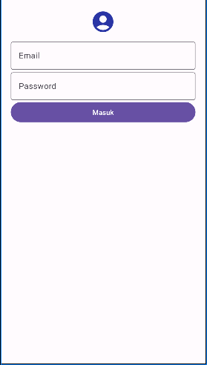

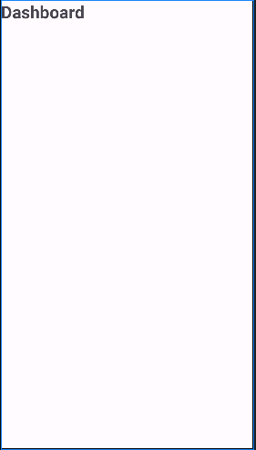

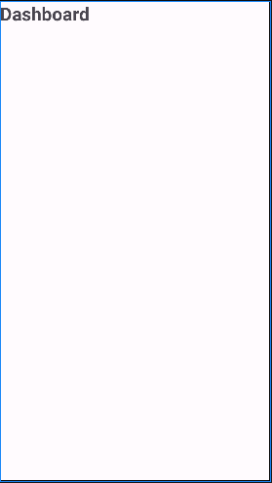

Tugas 2 mySecondChristopherApp:

Activity_main.xml

<?xml version="1.0" encoding="utf-8"?>

<LinearLayout xmlns:android="http://schemas.android.com/apk/res/android"

xmlns:app="http://schemas.android.com/apk/res-auto"

xmlns:tools="http://schemas.android.com/tools"

android:id="@+id/activity_main"

android:layout_width="match_parent"

android:layout_height="match_parent"

android:orientation="vertical"

tools:context=".MainActivity">

<TextView

android:layout_width="wrap_content"

android:layout_height="wrap_content"

android:text="Form Data Siswa"

android:id="@+id/heading"/>

<EditText

android:layout_width="match_parent"

android:layout_height="wrap_content"

android:hint="Isi nama anda"

android:id="@+id/isinama"/>

<RadioGroup

android:layout_width="match_parent"

android:id="@+id/radiogrup"

android:layout_height="wrap_content">

<RadioButton

android:layout_width="match_parent"

android:layout_height="wrap_content"

android:id="@+id/rdb1"

android:text="Laki-laki"

android:checked="true"/>

<RadioButton

android:layout_width="match_parent"

android:layout_height="wrap_content"

android:id="@+id/rdb2"

android:text="Perempuan"

android:checked="false"/>

</RadioGroup>

<CheckBox

android:layout_width="match_parent"

android:layout_height="wrap_content"

android:id="@+id/checkAgree"

android:text="Semua Yang Diisikan Benar"/>

<ImageButton

android:layout_width="match_parent"

android:layout_height="wrap_content"

android:src="@mipmap/ic_launcher"

android:onClick="hasil"/>

</LinearLayout>

MainActivity.java

package com.example.mysecondchristopherapp;

import android.graphics.Color;

import android.os.Bundle;

import android.view.View;

import android.widget.CheckBox;

import android.widget.EditText;

import android.widget.RadioButton;

import android.widget.RadioGroup;

import android.widget.TextView;

import androidx.activity.EdgeToEdge;

import androidx.appcompat.app.AppCompatActivity;

import androidx.core.graphics.Insets;

import androidx.core.view.ViewCompat;

import androidx.core.view.WindowInsetsCompat;

public class MainActivity extends AppCompatActivity {

private EditText Nama;

private RadioGroup jnskelamin;

private RadioButton LakiLaki;

private RadioButton perempuan;

private CheckBox setuju;

private TextView TampilNama;

private TextView TampilJenisKelamin;

private TextView TampilSetuju;

@Override

protected void onCreate(Bundle savedInstanceState) {

super.onCreate(savedInstanceState);

setContentView(R.layout.*activity_main*);

Nama = (EditText) findViewById(R.id.*isinama*);

jnskelamin = (RadioGroup) findViewById(R.id.*radiogrup*);

LakiLaki = (RadioButton) findViewById(R.id.*rdb1*);

perempuan = (RadioButton) findViewById(R.id.*rdb2*);

setuju = (CheckBox) findViewById(R.id.*checkAgree*);

}

public void hasil(View view) {

setContentView(R.layout.*halhasil*);

TampilNama = (TextView) findViewById(R.id.*tampilNama*);

TampilNama.setTextColor(Color.*WHITE*);

TampilNama.setBackgroundColor(Color.*BLUE*);

TampilNama.setText(Nama.getText());

TampilJenisKelamin=(TextView)findViewById(R.id.*tampilJenisKelamin*);

TampilJenisKelamin.setTextColor(Color.*WHITE*);

if (LakiLaki.isChecked()) {

TampilJenisKelamin.setBackgroundColor(Color.*GRAY*);

TampilJenisKelamin.setText("Laki-Laki");

}

if (perempuan.isChecked()) {

TampilJenisKelamin.setBackgroundColor(Color.*MAGENTA*);

TampilJenisKelamin.setText("perempuan");

}

TampilSetuju = (TextView) findViewById(R.id.*tampilSetuju*);

TampilSetuju.setTextColor(Color.*WHITE*);

if (setuju.isChecked()) {

TampilSetuju.setBackgroundColor(Color.*GREEN*);

TampilSetuju.setText("Semua Yang Di Isikan Benar");

} else {

TampilSetuju.setBackgroundColor(Color.*RED*);

TampilSetuju.setText("Ada yang salah");

}

}

}

String.xml:

<resources>

<string name="app_name">MYSecondChristopherApp</string>

<string name="isinama">isi nama anda</string>

</resources>

Halhasil.xml:

<?xml version="1.0" encoding="utf-8"?>

<LinearLayout xmlns:android="http://schemas.android.com/apk/res/android"

android:layout_width="match_parent"

android:layout_height="match_parent"

android:orientation="vertical">

<TextView

android:layout_width="match_parent"

android:layout_height="wrap_content"

android:id="@+id/tampilNama"

android:text="Tampil Nama"/>

<TextView

android:layout_width="match_parent"

android:layout_height="wrap_content"

android:id="@+id/tampilJenisKelamin"

android:text="Tampil Jenis Kelamin"/>

<TextView

android:layout_width="match_parent"

android:layout_height="wrap_content"

android:id="@+id/tampilSetuju"

android:text="Tampil Setuju"/>

</LinearLayout>

Output:

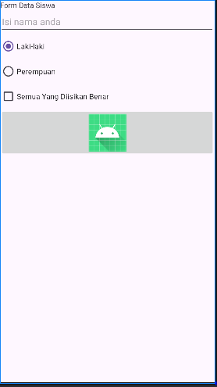

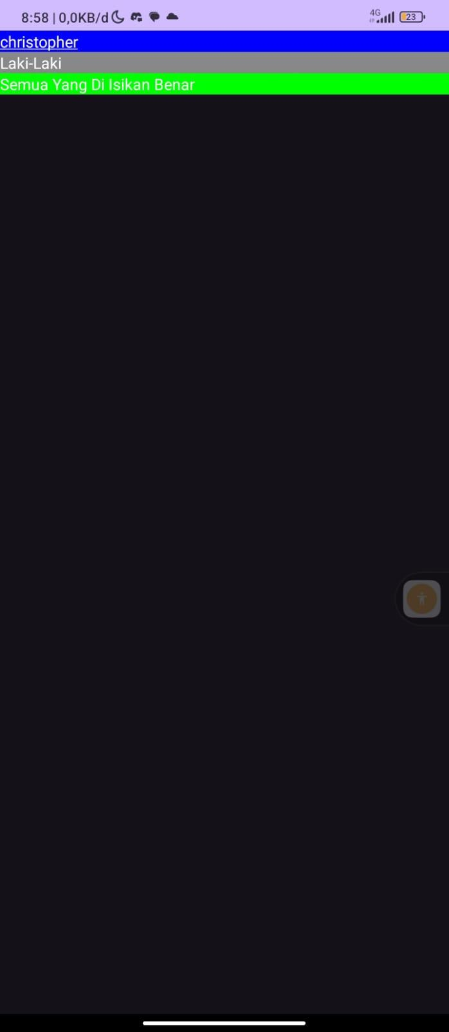

tugas3MyThirChristopherapplication:

Activity_main.xml

<?xml version="1.0" encoding="utf-8"?>

<LinearLayout xmlns:android="http://schemas.android.com/apk/res/android"

xmlns:app="http://schemas.android.com/apk/res-auto"

xmlns:tools="http://schemas.android.com/tools"

android:layout_width="match_parent"

android:layout_height="match_parent"

android:orientation="vertical"

android:padding="20dp"

tools:context=".MainActivity">

<ImageView

android:layout_width="wrap_content"

android:layout_height="wrap_content"

android:layout_gravity="center"

android:src="@drawable/ic_launcher_foreground"

android:layout_marginBottom="10dp"/>

<com.google.android.material.textfield.TextInputLayout

android:layout_width="match_parent"

android:layout_height="wrap_content">

<EditText

android:layout_width="match_parent"

android:layout_height="wrap_content"

android:hint="Email"

android:inputType="textEmailAddress"

android:id="@+id/etEmail"

/>

</com.google.android.material.textfield.TextInputLayout>

<com.google.android.material.textfield.TextInputLayout

android:layout_width="match_parent"

android:layout_height="wrap_content">

<EditText

android:id="@+id/etPassword"

android:layout_width="match_parent"

android:layout_height="wrap_content"

android:hint="Password"

android:inputType="textPassword"/>

</com.google.android.material.textfield.TextInputLayout>

<CheckBox

android:id="@+id/cbShowPassword"

android:layout_width="wrap_content"

android:layout_height="wrap_content"

android:text="Show Password"

android:layout_marginBottom="20dp"/>

<Button

android:id="@+id/btnlogin"

android:layout_width="match_parent"

android:layout_height="wrap_content"

android:layout_marginBottom="10dp"

android:text="Masuk" />

</LinearLayout>

MainActivity.java

package com.example.mythirdchristopherapplication;

import android.content.Intent;

import android.os.Bundle;

import android.view.View;

import android.widget.Button;

import android.widget.CheckBox;

import android.widget.EditText;

import android.widget.Toast;

import androidx.activity.EdgeToEdge;

import androidx.appcompat.app.AppCompatActivity;

public class MainActivity extends AppCompatActivity {

private EditText etEmail, etPassword;

private Button btnlogin;

private CheckBox cbShowPassword;

private String email = "christopher@gmail.com"; // Perbaiki email yang tidak valid

private String password = "admin";

@Override

protected void onCreate(Bundle savedInstanceState) {

super.onCreate(savedInstanceState);

EdgeToEdge.*enable*(this);

setContentView(R.layout.*activity_main*);

etEmail = findViewById(R.id.*etEmail*);

etPassword = findViewById(R.id.*etPassword*);

btnlogin = findViewById(R.id.*btnlogin*);

cbShowPassword = findViewById(R.id.*cbShowPassword*);

// Mengatur event listener untuk CheckBox

cbShowPassword.setOnCheckedChangeListener((buttonView, isChecked) -> {

if (isChecked) {

// Tampilkan password

etPassword.setInputType(android.text.InputType.*TYPE_CLASS_TEXT*);

} else {

// Sembunyikan password

etPassword.setInputType(android.text.InputType.*TYPE_CLASS_TEXT* | android.text.InputType.*TYPE_TEXT_VARIATION_PASSWORD*);

}

// Memindahkan kursor ke akhir teks setelah mengubah inputType

etPassword.setSelection(etPassword.getText().length());

});

btnlogin.setOnClickListener(view -> {

if (etEmail.getText().toString().equalsIgnoreCase(email) &&

etPassword.getText().toString().equalsIgnoreCase(password)) {

Intent login = new Intent(MainActivity.this, Dashboard.class);

startActivity(login);

Toast.*makeText*(MainActivity.this, "LOGIN BERHASIL", Toast.*LENGTH_SHORT*).show();

} else {

Toast.*makeText*(MainActivity.this, "Email atau Password Salah", Toast.*LENGTH_SHORT*).show();

}

});

}

}

AndroidManifest.xml

<?xml version="1.0" encoding="utf-8"?>

<manifest xmlns:android="http://schemas.android.com/apk/res/android"

xmlns:tools="http://schemas.android.com/tools">

<application

android:allowBackup="true"

android:dataExtractionRules="@xml/data_extraction_rules"

android:fullBackupContent="@xml/backup_rules"

android:icon="@mipmap/ic_launcher"

android:label="@string/app_name"

android:roundIcon="@mipmap/ic_launcher_round"

android:supportsRtl="true"

android:theme="@style/Theme.MythirdChristopherapplication"

tools:targetApi="31">

<activity android:name=".Dashboard"></activity>

<activity

android:name=".MainActivity"

android:exported="true">

<intent-filter>

<action android:name="android.intent.action.MAIN" />

<category android:name="android.intent.category.LAUNCHER" />

</intent-filter>

</activity>

</application>

</manifest>

Dashboard.xml

<?xml version="1.0" encoding="utf-8"?>

<LinearLayout xmlns:android="http://schemas.android.com/apk/res/android"

xmlns:app="http://schemas.android.com/apk/res-auto"

xmlns:tools="http://schemas.android.com/tools"

android:id="@+id/activity_main"

android:layout_width="match_parent"

android:layout_height="match_parent"

android:orientation="vertical"

tools:context=".MainActivity">

<TextView

android:layout_width="wrap_content"

android:layout_height="wrap_content"

android:text="Form Data Siswa"

android:id="@+id/heading"/>

<EditText

android:layout_width="match_parent"

android:layout_height="wrap_content"

android:hint="Isi nama anda"

android:id="@+id/isinama"/>

<RadioGroup

android:layout_width="match_parent"

android:id="@+id/radiogrup"

android:layout_height="wrap_content">

<RadioButton

android:layout_width="match_parent"

android:layout_height="wrap_content"

android:id="@+id/rdb1"

android:text="Laki-laki"

android:checked="true"/>

<RadioButton

android:layout_width="match_parent"

android:layout_height="wrap_content"

android:id="@+id/rdb2"

android:text="Perempuan"

android:checked="false"/>

</RadioGroup>

<CheckBox

android:layout_width="match_parent"

android:layout_height="wrap_content"

android:id="@+id/checkAgree"

android:text="Semua Yang Diisikan Benar"/>

<ImageButton

android:layout_width="match_parent"

android:layout_height="wrap_content"

android:src="@mipmap/ic_launcher"

android:onClick="hasil"/>

</LinearLayout>

Dashboard.java

package com.example.mythirdchristopherapplication;

import android.graphics.Color;

import android.os.Bundle;

import android.view.View;

import android.widget.CheckBox;

import android.widget.EditText;

import android.widget.RadioButton;

import android.widget.RadioGroup;

import android.widget.TextView;

import androidx.activity.EdgeToEdge;

import androidx.appcompat.app.AppCompatActivity;

import androidx.core.graphics.Insets;

import androidx.core.view.ViewCompat;

import androidx.core.view.WindowInsetsCompat;

import com.example.mythirdchristopherapplication.R;

public class Dashboard extends AppCompatActivity {

private EditText Nama;

private RadioGroup jnskelamin;

private RadioButton LakiLaki;

private RadioButton perempuan;

private CheckBox setuju;

private TextView TampilNama;

private TextView TampilJenisKelamin;

private TextView TampilSetuju;

@Override

protected void onCreate(Bundle savedInstanceState) {

super.onCreate(savedInstanceState);

setContentView(R.layout.*dashboard*);

Nama = (EditText) findViewById(R.id.*isinama*);

jnskelamin = (RadioGroup) findViewById(R.id.*radiogrup*);

LakiLaki = (RadioButton) findViewById(R.id.*rdb1*);

perempuan = (RadioButton) findViewById(R.id.*rdb2*);

setuju = (CheckBox) findViewById(R.id.*checkAgree*);

}

public void hasil(View view) {

setContentView(R.layout.*halhasil*);

TampilNama = (TextView) findViewById(R.id.*tampilNama*);

TampilNama.setTextColor(Color.*WHITE*);

TampilNama.setBackgroundColor(Color.*BLUE*);

TampilNama.setText(Nama.getText());

TampilJenisKelamin=(TextView)findViewById(R.id.*tampilJenisKelamin*);

TampilJenisKelamin.setTextColor(Color.*WHITE*);

if (LakiLaki.isChecked()) {

TampilJenisKelamin.setBackgroundColor(Color.*GRAY*);

TampilJenisKelamin.setText("Laki-Laki");

}

if (perempuan.isChecked()) {

TampilJenisKelamin.setBackgroundColor(Color.*MAGENTA*);

TampilJenisKelamin.setText("perempuan");

}

TampilSetuju = (TextView) findViewById(R.id.*tampilSetuju*);

TampilSetuju.setTextColor(Color.*WHITE*);

if (setuju.isChecked()) {

TampilSetuju.setBackgroundColor(Color.*GREEN*);

TampilSetuju.setText("Semua Yang Di Isikan Benar");

} else {

TampilSetuju.setBackgroundColor(Color.*RED*);

TampilSetuju.setText("Ada yang salah");

}

}

}

Halhasil.xml

<?xml version="1.0" encoding="utf-8"?>

<LinearLayout xmlns:android="http://schemas.android.com/apk/res/android"

android:layout_width="match_parent"

android:layout_height="match_parent"

android:orientation="vertical">

<TextView

android:layout_width="match_parent"

android:layout_height="wrap_content"

android:id="@+id/tampilNama"

android:text="Tampil Nama"/>

<TextView

android:layout_width="match_parent"

android:layout_height="wrap_content"

android:id="@+id/tampilJenisKelamin"

android:text="Tampil Jenis Kelamin"/>

<TextView

android:layout_width="match_parent"

android:layout_height="wrap_content"

android:id="@+id/tampilSetuju"

android:text="Tampil Setuju"/>

</LinearLayout>

String.xml

<resources>

<string name="app_name">MythirdChristopherapplication</string>

<string name="isinama">isi nama anda</string>

</resources>

Hasil:

